Date: 31/01/2026
Aim:
Windows Fundamentals Windows Fundamentals 1

To understand core Windows operating system concepts including file systems, user management, UAC, Control Panel, and Task Manager.
To view this room: https://tryhackme.com/room/windowsfundamentals1 Topics:
- Windows Editions
- The File System
- Windows / System 32 Folders
- Users
- UAC
- Control Panel
- Task Manager

Answers
- Windows Editions
- Windows XP
- Windows Vista
- Windows 7
- Windows 10
- Windows 11
Note: In Windows 11 Pro, you can enable BitLocker encryption which you cannot do in Windows 11 Home.

The File System
In modern versions of Windows, the file system used is NTFS. Before NTFS (New Technology File System), there was FAT16/FAT32 (File Allocation Table) and HPFS (High-Performance File System). You still see FAT partitions in use today. For example, you typically see FAT partitions in USB devices, MicroSD cards, etc. but traditionally not on personal Windows computers/laptops or Windows servers.

NTFS addresses many of the limitations of the previous file systems; such as:
Supports files larger than 4GB
Set specific permissions on folders and files Folder and file compression
Encryption (Encryption File System) or EFS
Another feature of NTFS is ADS (Alternate Data Stream) which allows files to contain more than one stream of data.

Windows / System 32 Folders
The Windows folder (C:\Windows) is traditionally known as the folder which contains the Windows operating system. The folder doesn't have to reside in the C drive necessarily. It can reside in any other drive and technically can reside in a different folder.

This is where environment variables, more specifically system environment variables, come into play. Even though not discussed yet, the system environment variable for the Windows directory is %windir%.
The System32 folder holds the important files that are critical for the operating system.

Users
User accounts can be one of two types on a typical local Windows system: Administrator & Standard User. The user account type will determine what actions the user can perform on that specific Windows system.
An Administrator can make changes to the system: add users, delete users, modify groups, modify settings on the system, etc.
A Standard User can only make changes to folders/files attributed to the user & can’t perform system-level changes, such as install programs.
Run the command lusrmgr.msc to view the Local User & Group Management tab.

UAC
A user doesn’t need to run with high (elevated) privileges on the system to run tasks that don’t require such privileges, such as surfing the Internet, working on a Word document, etc. This elevated privilege increases the risk of system compromise because it makes it easier for malware to infect the system. Consequently, since the user account can make changes to the system, the malware would run in the context of the logged-in user.

UAC (User Account Control) was introduced to protect the local user with such privileges but doesn’t apply to the local administrator account by default.
How does UAC work? When a user with an account type of administrator logs into a system, the current session doesn’t run with elevated permissions. When an operation requiring higher-level privileges needs to execute, the user will be prompted to confirm if they permit the operation to run.

Control Panel
The Settings menu was introduced in Windows 8, the first Windows operating system catered to touchscreen tablets. The Control Panel is the menu where you will access more complex settings and perform more complex actions. In some cases, you can start in Settings and end up in the Control Panel.

Task Manager
The Task Manager provides information about the applications and processes currently running on the system. Other information is also available, such as how much CPU and RAM are being utilized, which falls under Performance.

Answers Task 2
- What encryption can you enable on Pro that you can’t enable in Home? BitLocker

Task 3
- Which selection will hide/disable the Search box? Hidden
- Which selection will hide/disable the Task View button? Show task view button
- Besides Clock and Network, what other icon is visible in the Notification Area? Action Center

Task 4
- What is the meaning of NTFS? New Technology File System

Task 5
- What is the system variable for the Windows folder?
%windir%

Task 6
- What is the name of the other user account? tryhackmebilly
- What groups is this user a member of? Remote Desktop Users, Users
- What built-in account is for guest access to the computer? Guest
- What is the account description? window$Fun1!

Task 7
- What does UAC mean? User Account Control

Task 8
- In the Control Panel, change the view to Small icons. What is the last setting in the Control Panel view?
Windows Defender Firewall

Task 9
- What is the keyboard shortcut to open Task Manager? Ctrl+Shift+Esc
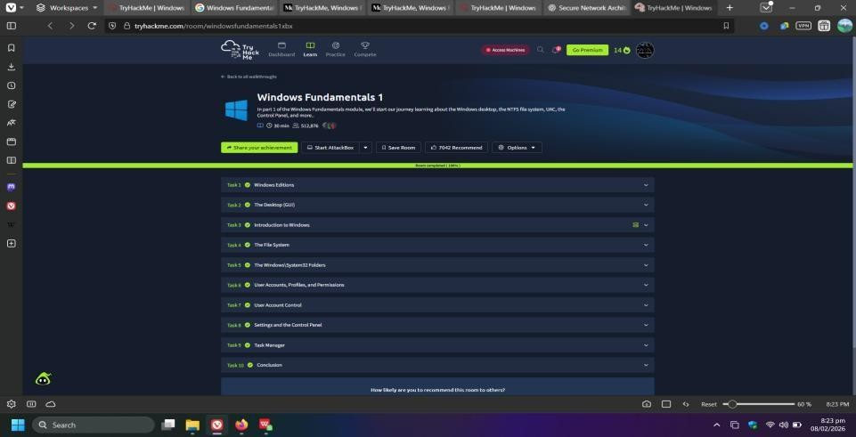

Windows Fundamentals 2

Lab link:https://tryhackme.com/room/windowsfundamentals2x0x

Task 1 Introduction
#1. Launch the attached virtual machine
In this task, we should launch the virtual machine by clicking on the button “Start Machine.”
Press enter or click to view image in full size
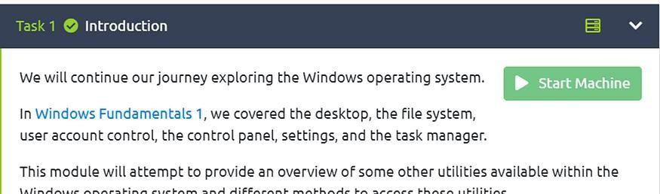
Answer: No answer is needed.

Task 2 System Configuration
#2.1 What is the name of the service that lists Systems Internals as the manufacturer? Before responding to this question, we need to be clear about what System configuration is.
System Configuration: it is used for advanced troubleshooting, and its main purpose is to help diagnose startup issues.
To respond to this question, we should follow the next steps:
First, exist different methods to launch the “System Configuration” tool, but in this case, we use the app “run” and type “msconfig”.
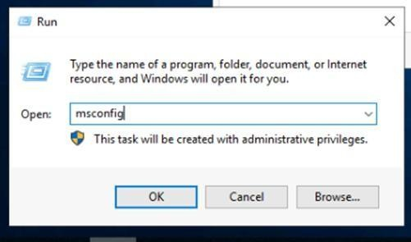
Second, the app pops on the screen, as we can see in the following image. Then, we should click on the “Services” tab, and search for System internals. Press enter or click to view image in full size

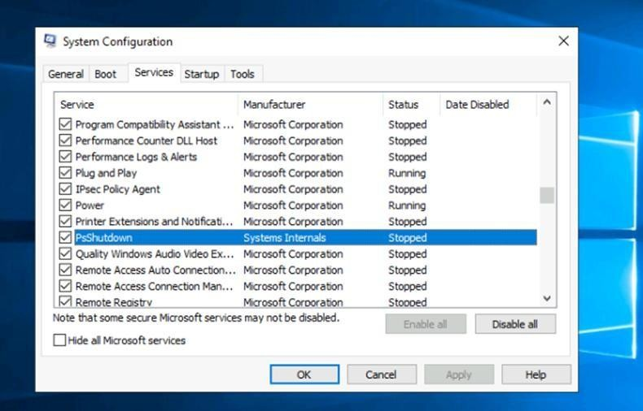
Answer: PsShutdown
#2.2 Whom is the Windows license registered to?
To respond to this question, we should follow the next steps: We should click on the “Tools” tab and select “About windows”. Press enter or click to view image in full size
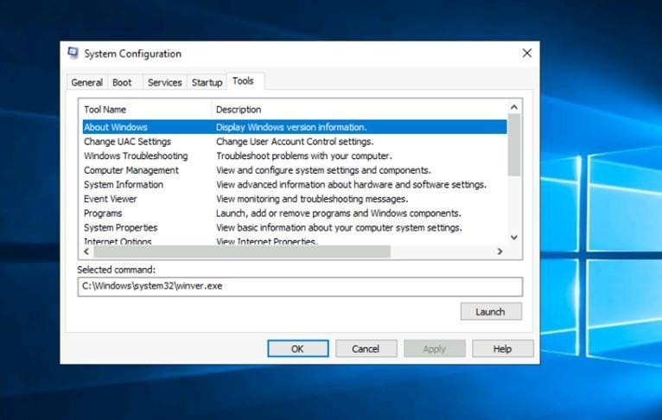
Then Press launch.
As we can see in the following image, we can find our answer.

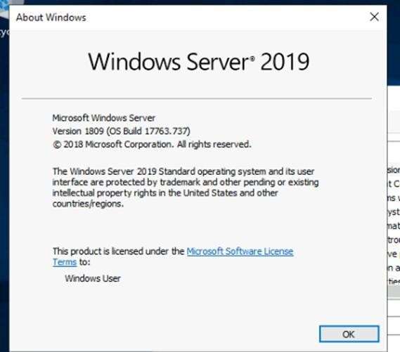
Answer: Windows User
#2.3 What is the command for Windows Troubleshooting? To respond to this question, we should follow the next steps:
We should click on the “Tools” tab and select “Windows Troubleshooting”. We can find our answer in the “Selected command.”
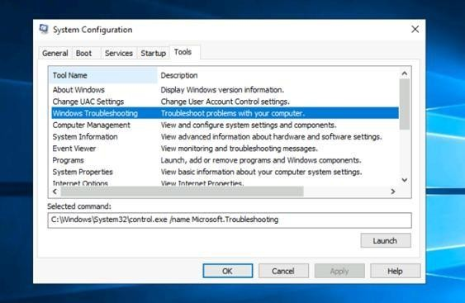

Answer: C:\Windows\System32\control.exe /name Microsoft.Troubleshooting #2.4 What command will open the Control Panel? (The answer is the name of .exe, not the full path)
To respond to this question, we should follow the next step:
We should click on the “Tools” tab and select “System Properties”. Press enter or click to view image in full size
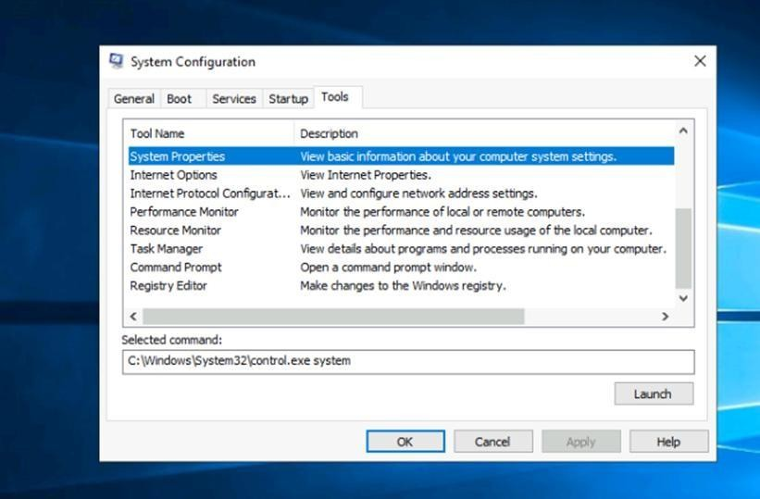
Answer: control.exe

Task 3 Change UAC Settings
#3.1 What is the command to open User Account Control Settings? (The answer is the name of the .exe file, not the full path)
To respond to this question, we should follow the next step:
We should click on the “Tools” tab and select “Change UAC Settings”. Press enter or click to view image in full size
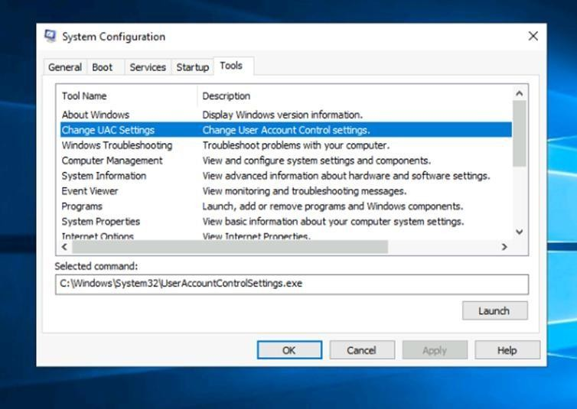

Answer: UserAccountControlSettings.exe

Task 4 Computer Management
#4.1 What is the command to open Computer Management? (The answer is the name of the .msc file, not the full path)
To respond to this question, we should follow the next step:
We should click on the “Tools” tab and select “Computer Management”.
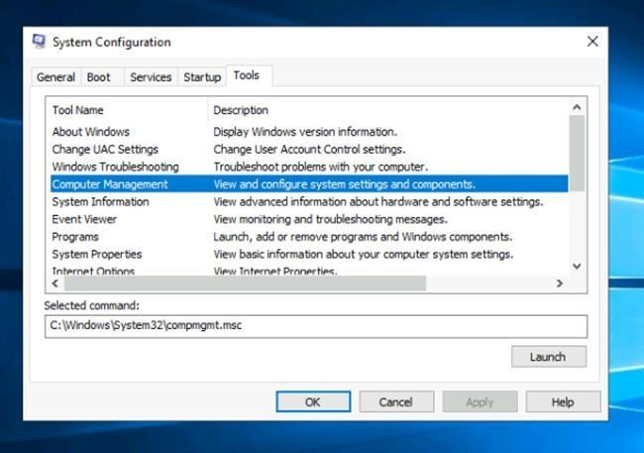
Answer:compmgmt.msc
#4.2 At what time every day is the GoogleUpdateTaskMachineUA task configured to run?
To respond to this question, we should follow the next steps:
We should use the app “run” and type “compmgmt.msc”. This command opens the tool Computer Management.
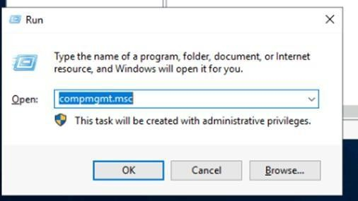

Press enter or click to view image in full size
Then, we need to go to System Tools < Task Scheduler <Task Scheduler Library, as we can see in the following image:
We can notice that this task is scheduled at 6:15 AM. Press enter or click to view image in full size
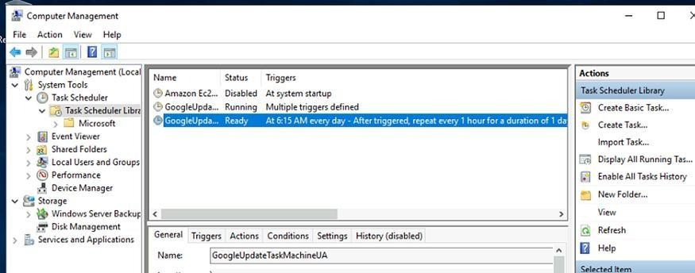
Computer Management: It is a Microsoft Windows utility that provides a centralized view of system settings and performance information.
GoogleUpdateTaskMachineUA: It is a Microsoft Windows scheduled task that is created by Google Chrome and other Google software.
Answer: 6:15 AM
#4.3 What is the name of the hidden folder that is shared? To respond to this question, we should follow the next step:
We need to go to System Tools < Shared folders < Shares, as we can see in the following image:
Press enter or click to view image in full size
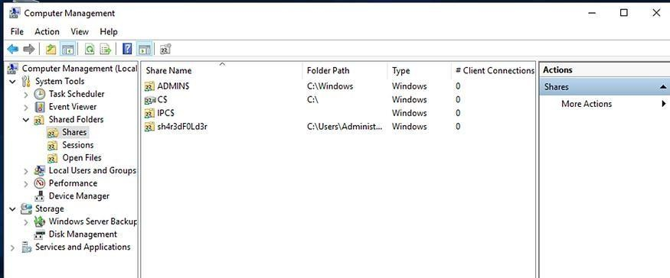
Answer:sh4r3dF0ld3rsh4r3dF0ld3r

Task 5 System Information
#5.1 What is the command to open System Information? (The answer is the name of the .exe file, not the full path)
The command to open System Information is “msinfo32.exe” Press enter or click to view image in full size
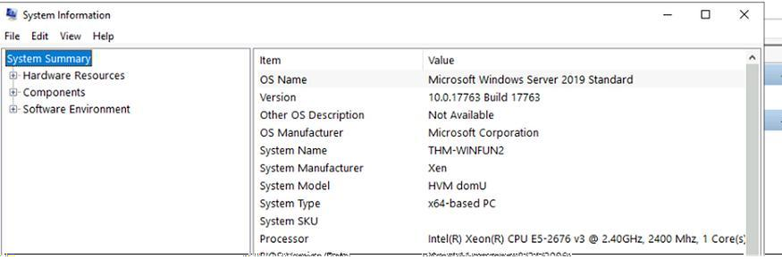

Answer: msinfo32.exe
#5.2 What is listed under System Name?
We should open “System Information” and select System Summary. We will find our response in System Name.
Press enter or click to view image in full size
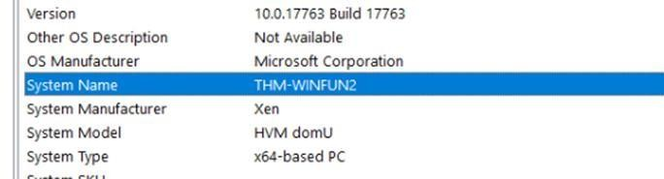
Answer: THM-WINFUN2
#5.3 Under Environment Variables, what is the value for ComSpec? To respond to this question, we should follow the next step:
We should go Software Environment < Environment Variable. Then, we can find our answer.
Press enter or click to view image in full size
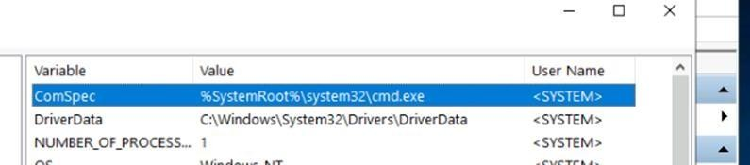
Answer: %SystemRoot%\system32\cmd.exe Task 6 Resource Monitor
#6.1 What is the command to open Resource Monitor? (The answer is the name of the .exe file, not the full path)
The command to open Resource Monitor is resmon.exe. As we can see in the following image:

Press enter or click to view image in full size
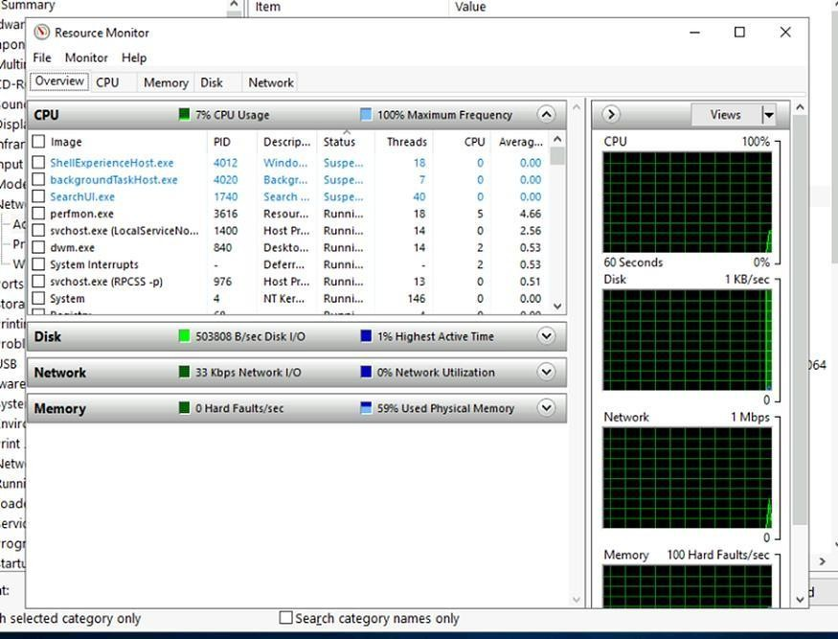
Answer: resmon.exe

Task 7 Command Prompt
#7.1 In System Configuration, what is the full command for Internet Protocol Configuration?
To respond to this question, we should follow the next step:
We should click on the “Tools” tab and select “Internet Protocol Configuration”. As we can see in the following image, we can find our answer:
Press enter or click to view image in full size
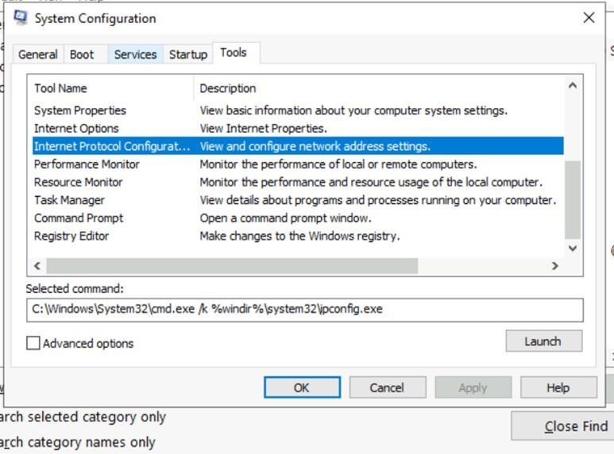

Answer:C:\Windows\System32\cmd.exe /k %windir%\system32\ipconfig.exe

7.2 For the ipconfig command, how do you show detailed information?
To respond to this question, we should type the following command to see the result: ipconfig /all
Press enter or click to view image in full size
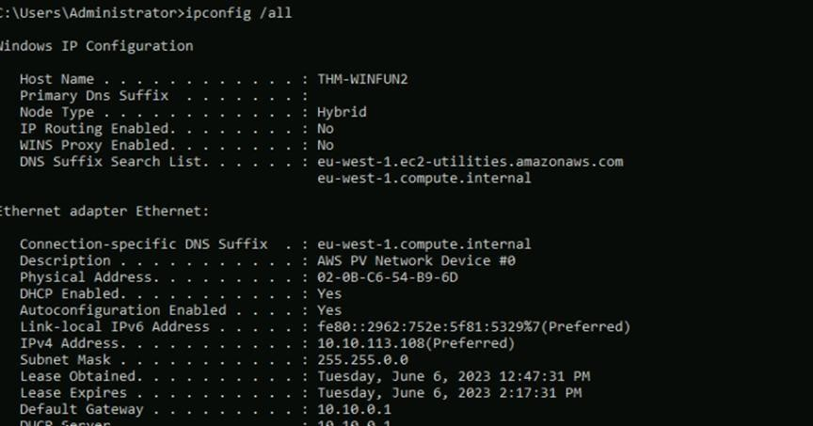
Answer: ipconfig /all

Task 8 Registry Editor
#8.1 What is the command to open the Registry Editor? (The answer is the name of the .exe file, not the full path)
To open the Registry Editor, we should type this command: regedt32.exe. Press enter or click to view image in full size
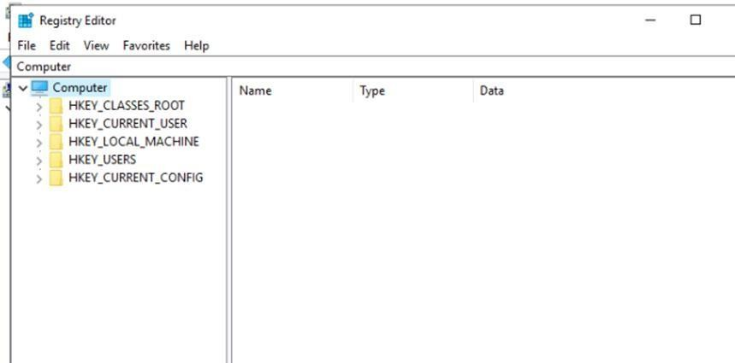
Answer: regedt32.exe

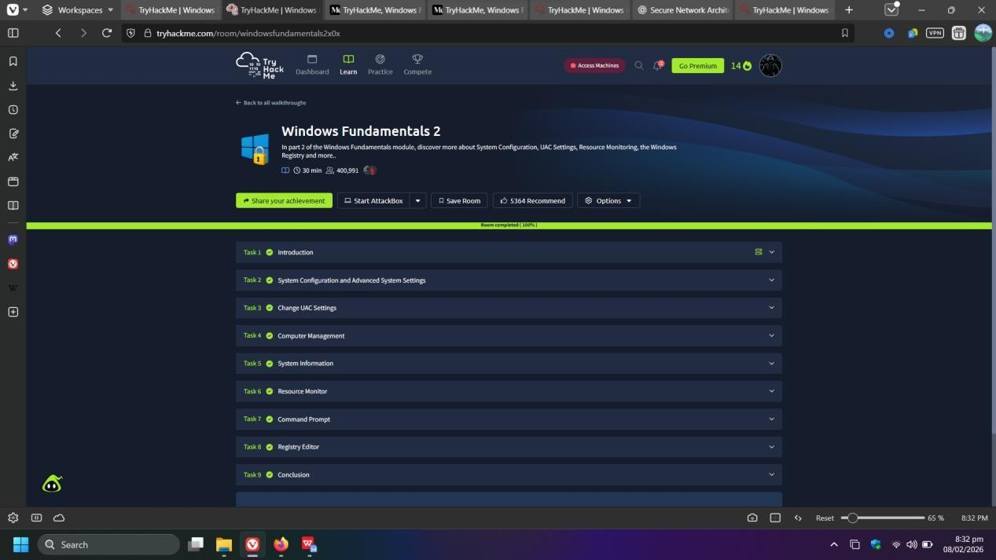

Windows Fundamentals 3
To view this room: https://tryhackme.com/room/windowsfundamentals3

Topics:
- Windows Updates
- Windows Security
- BitLocker
- Volume Shadow Copy Service
- Answers
- Windows Updates
This is a service provided by Microsoft to provide security updates, feature enhancements and patches for the Windows OS and other products such as Microsoft Defender.
Throughout the years, Windows users have grown accustomed to pushing Windows Updates off to a later date or not installing the updates at all. Various reasons caused this action, one being the fact that a reboot is typically required after a Windows update.
Microsoft notably addressed this issue with Windows 10. The updates can no longer be ignored or pushed to the side until forgotten. Windows updates can only be postponed, but eventually, the update will happen, and your computer will reboot. Microsoft provides these updates to keep the device safe and secure.

Windows Security
This is (according to Microsoft): “your home to manage the tools that protect your device and data.”

Some information on the status icons:
- Green | Your device is sufficiently protected
- Yellow | There is a safety recommendation for you to review
- Red | Warning the user that something needs your immediate attention

Virus & Threat Protection
There are a few scan options which include quick, full, or customs scans. There are also types of threat history which include the last scan, quarantined threats, and allowed threats.

Some settings which can be managed:
“Real-time protection” | Locates and stops malware from installing or running on your device.
“Cloud-delivered protection” | Provides increased and faster protection with access to the latest protection data in the cloud.
“Automatic sample submission” | Send sample files to Microsoft to help protect you and others from potential threats.
“Controlled folder access” | Protect files, folders, and memory areas on your device from unauthorized changes by unfriendly applications.

“Exclusions” | Windows Defender Antivirus won’t scan items you’ve excluded. “Notifications” | Windows Defender Antivirus will send notifications with critical information about the health and security of your device.

Firewall & Network Protection
A firewall controls and protects (a network or system) from unauthorized access. What are the differences between the 3 options on the firewall page?
Domain | This applies to networks where the host system can authenticate to a domain controller.
Private | This is a user-assigned profile and is used to designate private or home networks.
Public | This is used to designate public networks such as Wi-Fi hotspots at coffee shops and airports.
You can view the current settings for any firewall profile. Some of the apps will provide additional information if it’s available via the Details button.
The command to open Windows Defender Firewall is WF.msc.

App & Browser Control
Microsoft Defender SmartScreen protects against phishing or malware websites and applications, and the downloading of potential malicious files. Exploit protection is built into Windows as well.

Device Security
On the settings screen, the option “Core Isolation” is a virtualization-based security running to protect the core parts of your device. The memory integrity option prevents attacks from inserting malicious code into high-security processes.
Another setting is “Security Processor Details” which gives information about the Trusted Platform Module (TPM). The TPM is a technology which is designed to provide hardware-based, security-related functions. A TPM chip is a secure crypto-processor that is designed to carry out cryptographic operations. The chip includes multiple physical security mechanisms to make it tamper-resistant, and malicious software is unable to tamper with the security functions.

BitLocker
BitLocker Drive Encryption is a data protection feature that integrates with the OS and addresses the threats of data theft or exposure from lost, stolen, or inappropriately decommissioned computers.
According to Microsoft, when BitLocker is used with TPM. The TPM is a hardware component installed in many newer computers by computer manufacturers. It works with BitLocker to help protect user data and to ensure that a computer has not been tampered with while the system is offline.

Volume Shadow Copy Service
The VSS (Volume Shadow Copy Service) coordinates the required actions to create a consistent shadow copy of the data that is to be backed up.

If VSS is enabled on a system:
- Create a restore point
- Perform system restore
- Configure restore settings
- Delete restore points Answers

Task 2
A. There were two definition updates installed in the attached VM. On what date were these updates installed?
5/3/2021

Task 3
A. In the above image, which area needs immediate attention? Virus & threat protection

Task 4
A. Specifically, what is turned off that Windows is notifying you to turn on? Real-time protection

Task 5
- If you were connected to airport Wi-Fi, what most likely will be the active firewall profile?
Public network

Task 7
- What is the TPM? Trusted Platform Module

Task 8
- What must a user insert on computers that DO NOT have a TPM version 1.2 or later?
USB startup key

Task 9
- What is VSS?
Volume Shadow Copy Service
That’s all for today! If you didn’t understand something, make sure to do some research on it, search for a video on YouTube, etc.
I’ve covered the third section of the Windows Fundamentals module for the Pre-Security Pathway. Until the next one…

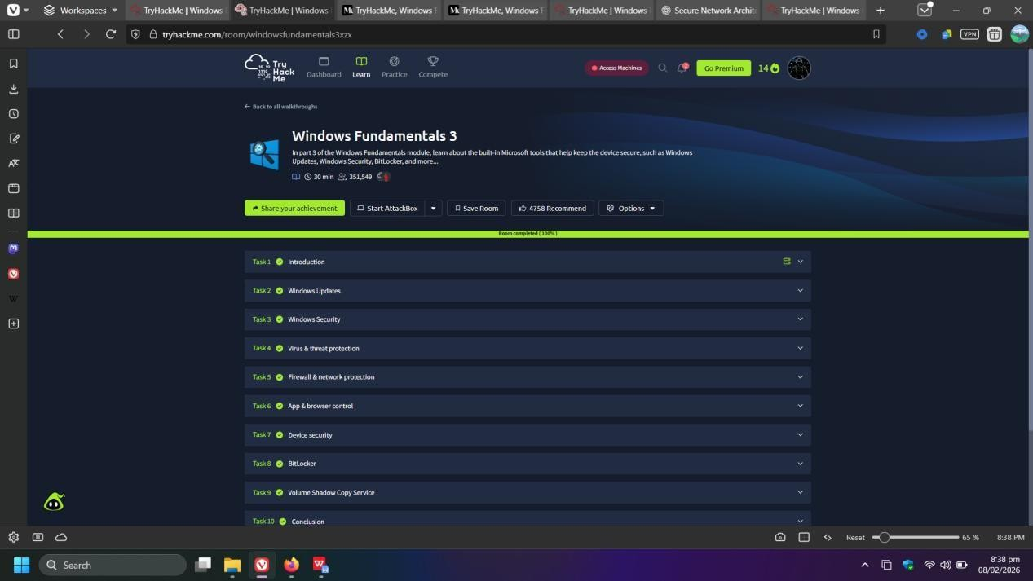

Result:
Successfully explored Windows editions, NTFS features, user accounts, system folders, and security mechanisms like UAC.

